What do you think? Are these convenient? Inconvenient? Comfortable? Uncomfortable?


This path has a ___________ white bench. This is a most ___________ chair.

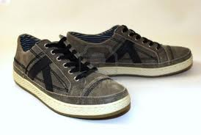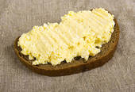
A pair of ___________ old shoes. Not healthy, but __________ for a picnic.

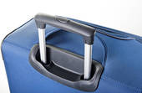
A most ___________ way to get around. A ___________ handle for a suitcase.

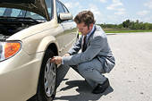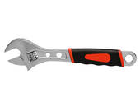
A flat tire is always ___________. This is a very ___________ wrench.


A very ___________ store if you are lost He’s feeling a bit ___________, isn’t he?
in the woods


Some ___________ obstacles on the road. He couldn’t be more ___________.

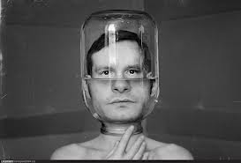
The most ___________ of all modern devices. Very ___________ headgear.


Very ___________ for photo sessions and most ___________ to boot.

convenient
adjective

Definition
•
suitable for your purposes and needs and causing the least difficulty
Our local shop has very convenient opening hours.
A bike's a very convenient way of getting around.
[+ that ] It's very convenient that you live near the office.
[+ to infinitive] I find it convenient to be able to do my banking by phone.
What time would it be convenient for me to come round?
Opposite: inconvenient
•
near or easy to get to or use
a very convenient bus service
Our new flat is very convenient for (= near to) the kids' school.
conveniently adverb
The house is conveniently situated near the station and the shops.
humorous I asked her to tidy the kitchen but of course she conveniently forgot
(= she forgot because she did not want to do it).

comfortable
adjective
CLOTHES/FURNITURE )

Definition
•
describes furniture and clothes that provide a pleasant feeling and that do not give you any physical problems
a comfortable bed/sofa
comfortable shoes/trousers
•
free from stress or anxiety; at ease: not comfortable about the interview.
•
producing feelings of ease or security: a comfortable person; a comfortable evening at home.
•
sufficient to provide financial security: comfortable earnings.

On February 21, 2002, the painting was returned to the Jewish Museum in Manhattan, and was inspected by Bella Meyer, granddaughter of the famous artist and a leading authority on his work. She confirmed that it was genuine. The painting is now comfortable back home in St-Petersburg, on display in the Russian Museum.

